**Getting started with business side logic of ConvergedConferenceApp “dlgmsc_conf” project in Eclipse**

**Note: Know issue that when using Eclipse other than Linux version causes the application not to work in TeleStax Application Server. Once solution is found update will be posted.**

Below are the steps on how to bring dlgmsc_conf project up on your local system for development/debugging purposes.

1. Install latest JDK (JDK 1.7 U 71 used here as an example)
2. Install Eclipse IDE (Eclipse Luna 4.4.1 used here as an example)

* Start Eclipse and configure it for appropriate JDK as installed in step 1).

To do that, open up newly installed Eclipse and go to “Window”->”Prefrences”:

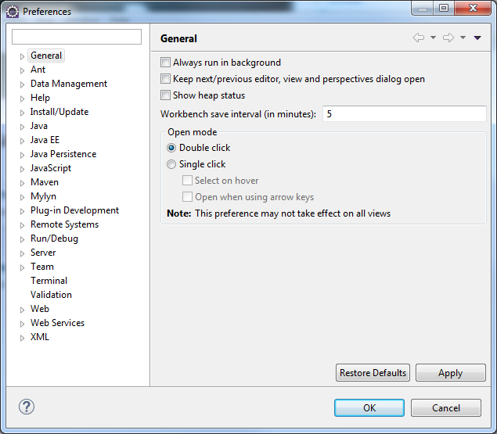

There select “Java”->”Installed JREs”:

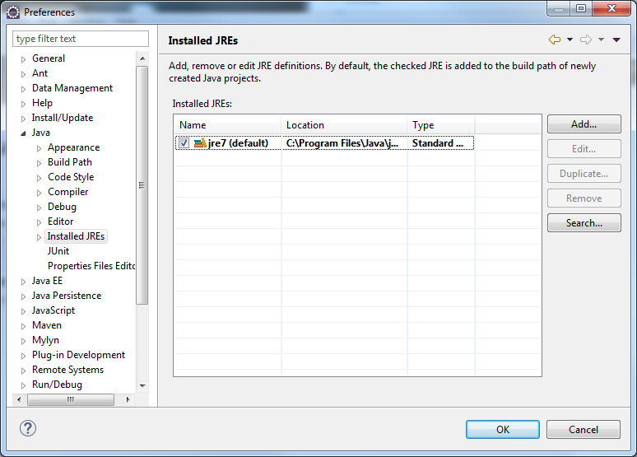

You might notice that Eclipse selected “jre 7” by default. This need to be changed and a reference to just installed JDK needs to be created. To do that click on “Add” button:

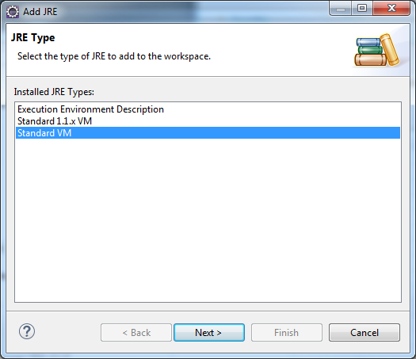

Select “Standard VM” and click “Next” button:

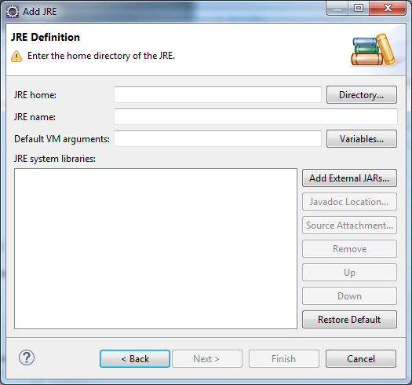

Here, click “Directory” button:

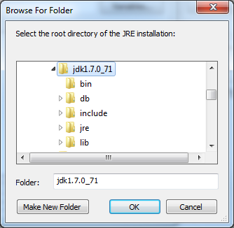

Navigate to the location of your JDK installation and click “OK” button:

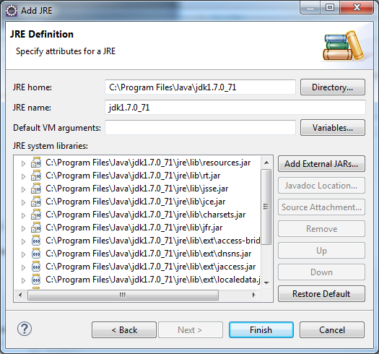

Now, click “Finish” button:

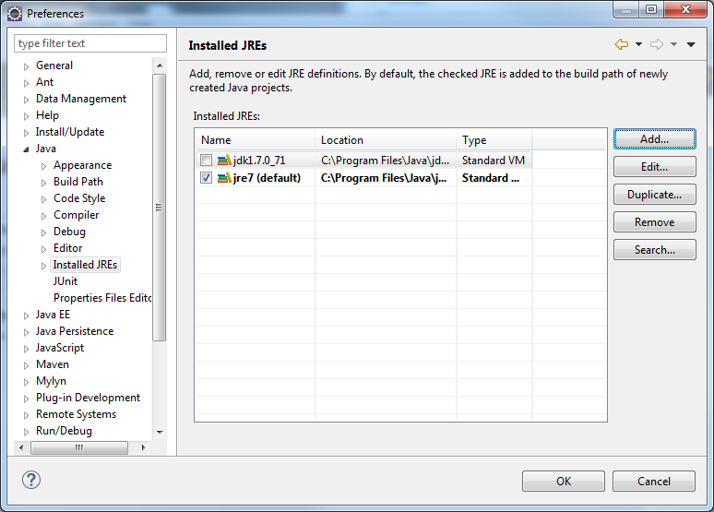

At this point jdk1.7.0_71 needs to be the only item selected. To do that, deselect jre7 and select jdk1.7.0_71 and then click “OK” button.

1. Now, unzip the project file dlgmsc_conf.tar and place its content in a known directory. Note, it needs to reside outside of the Eclipse workspace directory.
2. To open the project in Eclipse follow these simple steps:

* Open Eclipse:

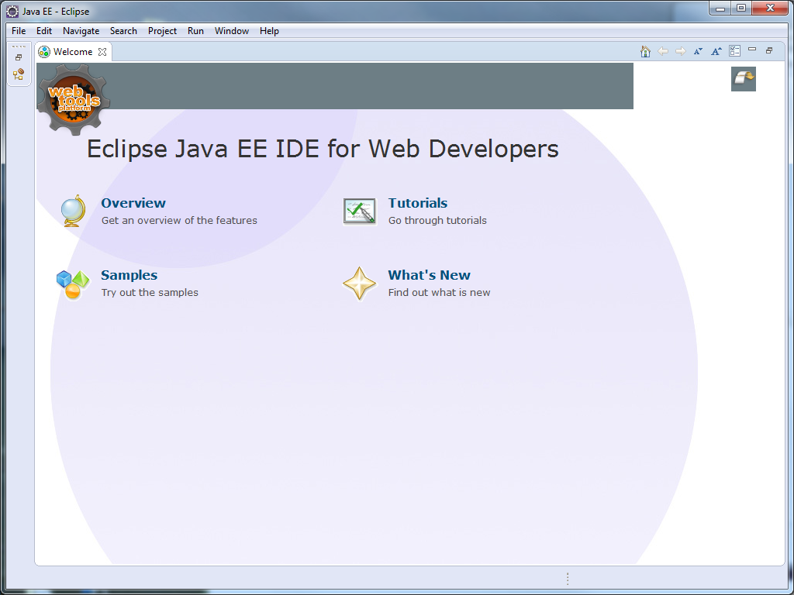

* Go to “File” menu

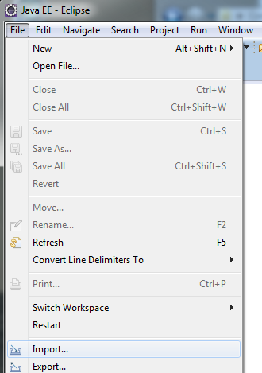

* Click “Import”:

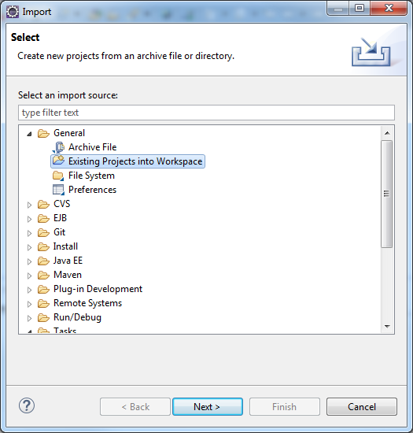

* Select “Existing Projects into Workspace” and click “Next”:

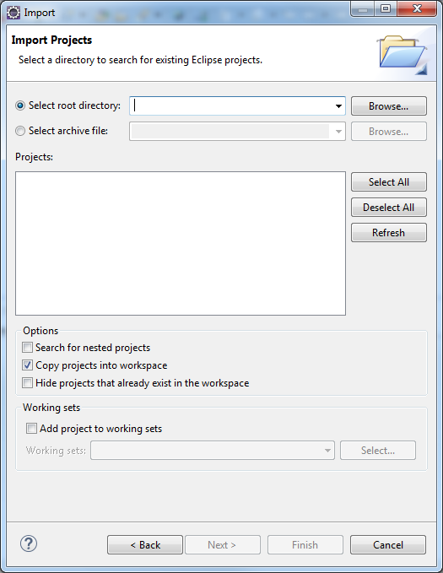

* click “Browse” button:

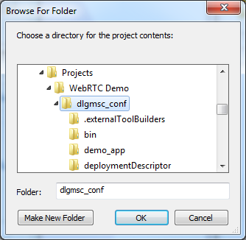

* Navigate to your project directory as created in step 3) and click “OK”:

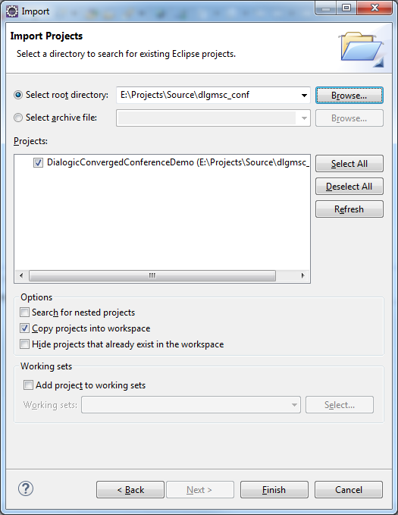

* Make sure “Copy projects into workspace” is selected and then click “Finish” button:
* Now, you should see your project appear in “Package Explorer”:

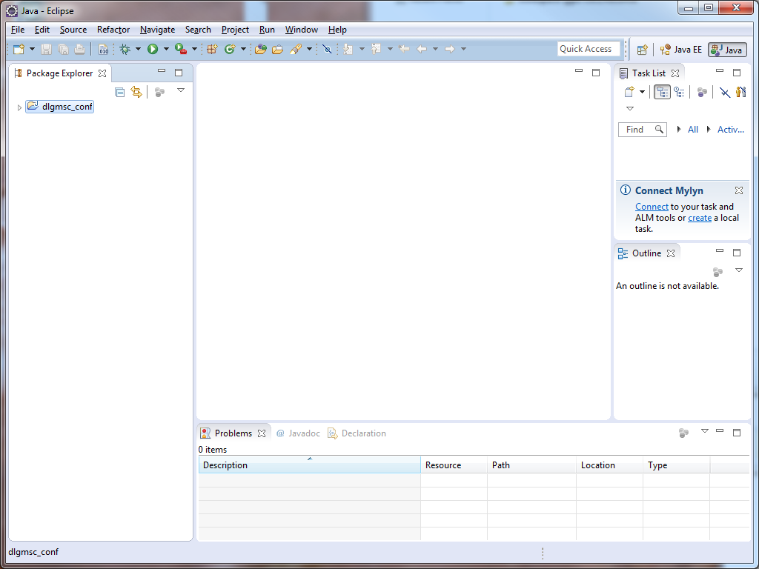

* Next, right mouse click on dlgmsc_conf and click Properties:

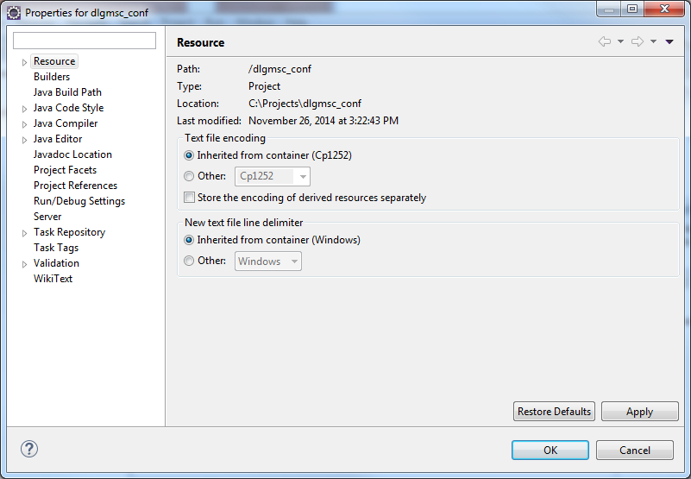

* Click on Builders:

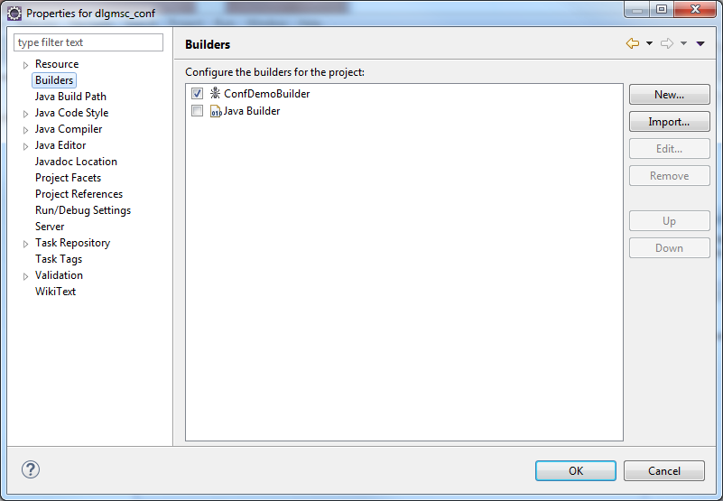

* Here double click on “ConfDemoBuilder” in order to set the right project properties to your local directory structure etc:

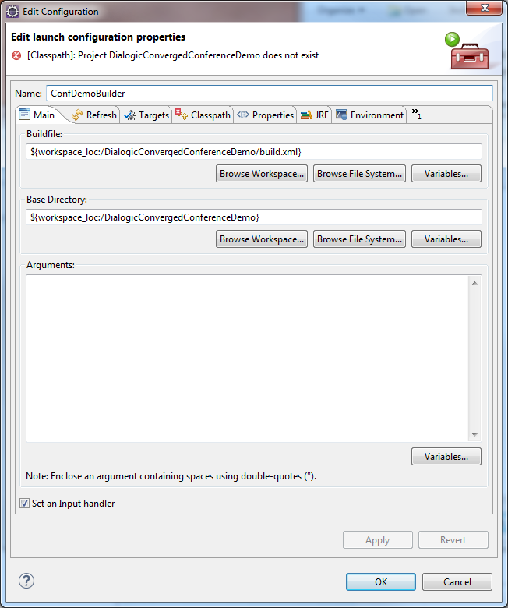

* Under “Buildfile:” click “Browse Workspace”:

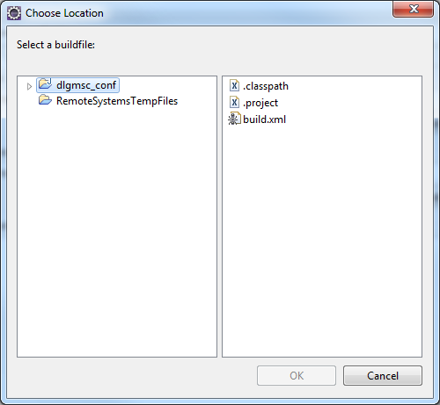

* Click “build.xml” and click “OK” button:

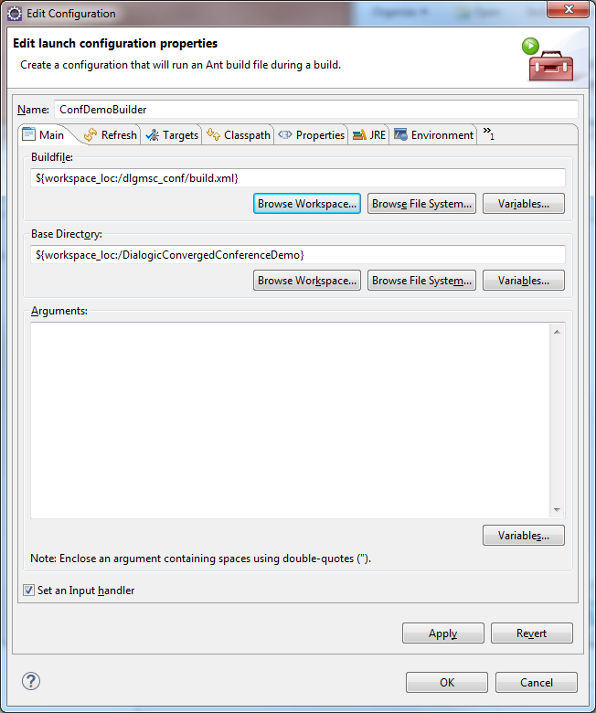

* Now, under “Base Directory:” click “Browse Workspace” button:

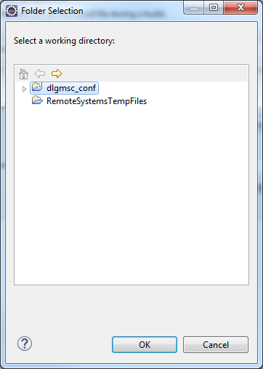

* Select “dlgmsc_conf” and click “OK” button:

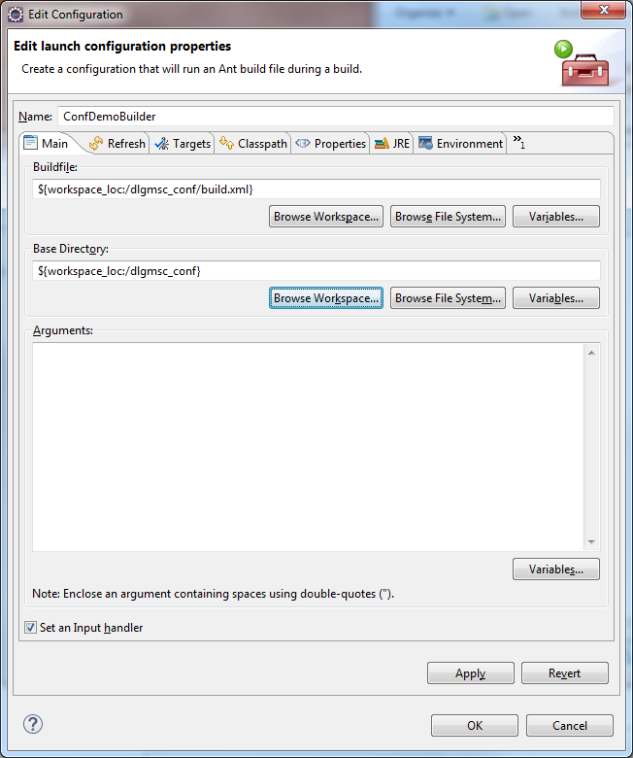

* Click “Apply” and then “OK” button:

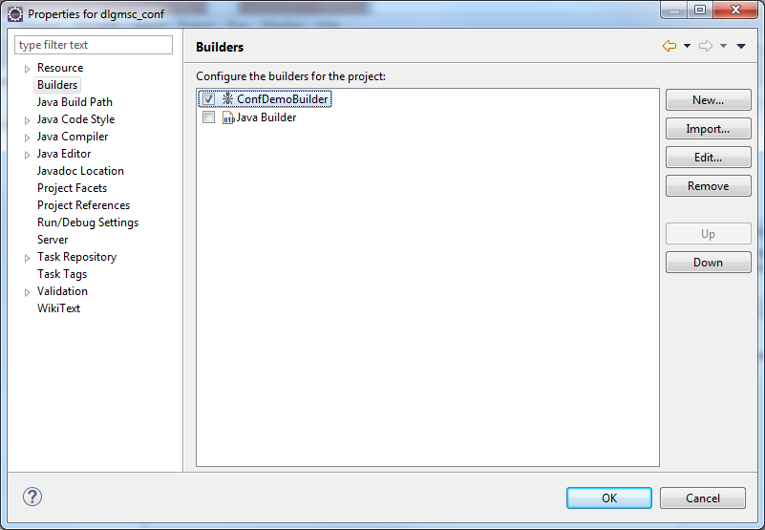

* Click “OK”. At this point you see Eclipse executing a build of the application. Successful build of the application will be indicated in a Console window of Eclipse project as following:

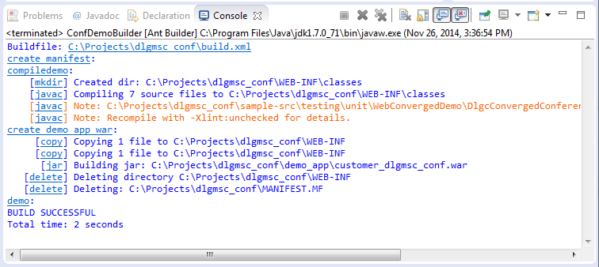

* At this point the new version of the business side of Converged Conference Application has been created and it can be used do deploy in TeleStax Application Server replacing the original as provided with a package.